Yazhuo Liu
Extra credit homework

Use blender to create a 3D 'human' graphics object with the following approximations:
- Head -- sphere
- body -- rectangular box
- upper arm -- rectangular box
- lower arm -- rectangular box
- hand -- sphere
- upper leg -- rectangular box
- lower leg -- rectangular box
- foot -- sphere
List clearly each step of your creation (e.g. what menu steps you need to click to create a box .. ). Give intermediate screenshots that show both the blender menu and the object in the creation process.

Final look:
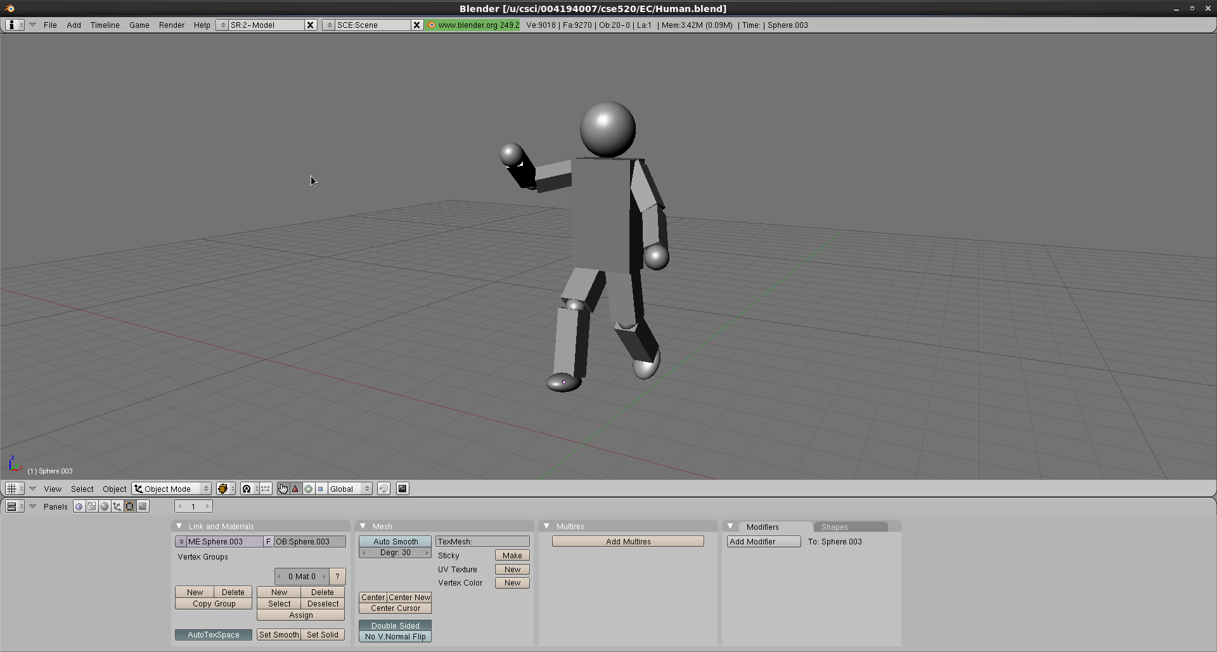

Firstly, I modified the original cube to make it look like the body. I used grab/move (G), scale (S, X or Y or Z) and rotate (R, X or Y or Z) to achieve my goal.
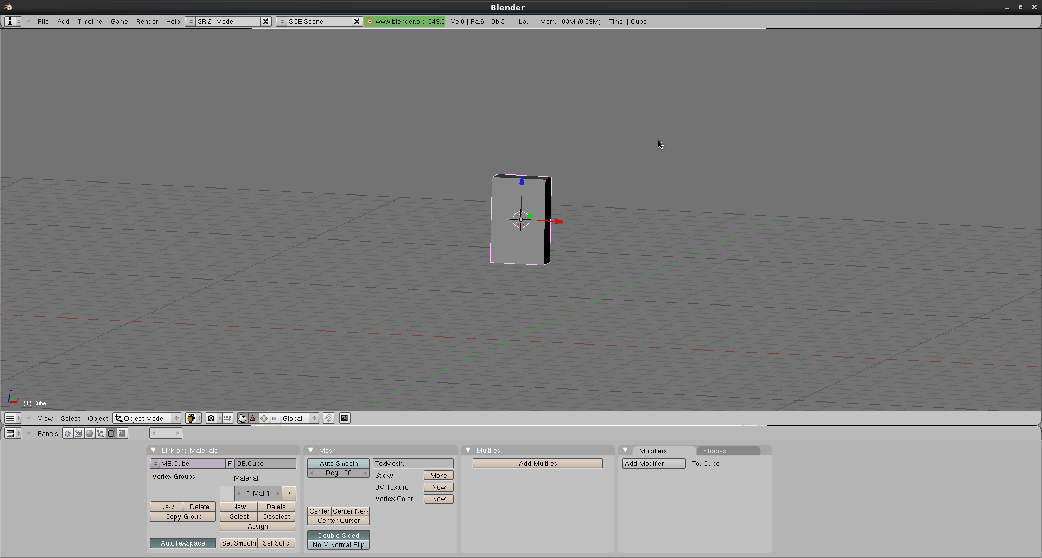

Then I add a sphere from add – mesh – uvsphere, and select Set Smooth to get rid of the rough surface. Then I modify the sphere to make it the head, and add another rectangular box to be the arm.
(add – mesh – cube)

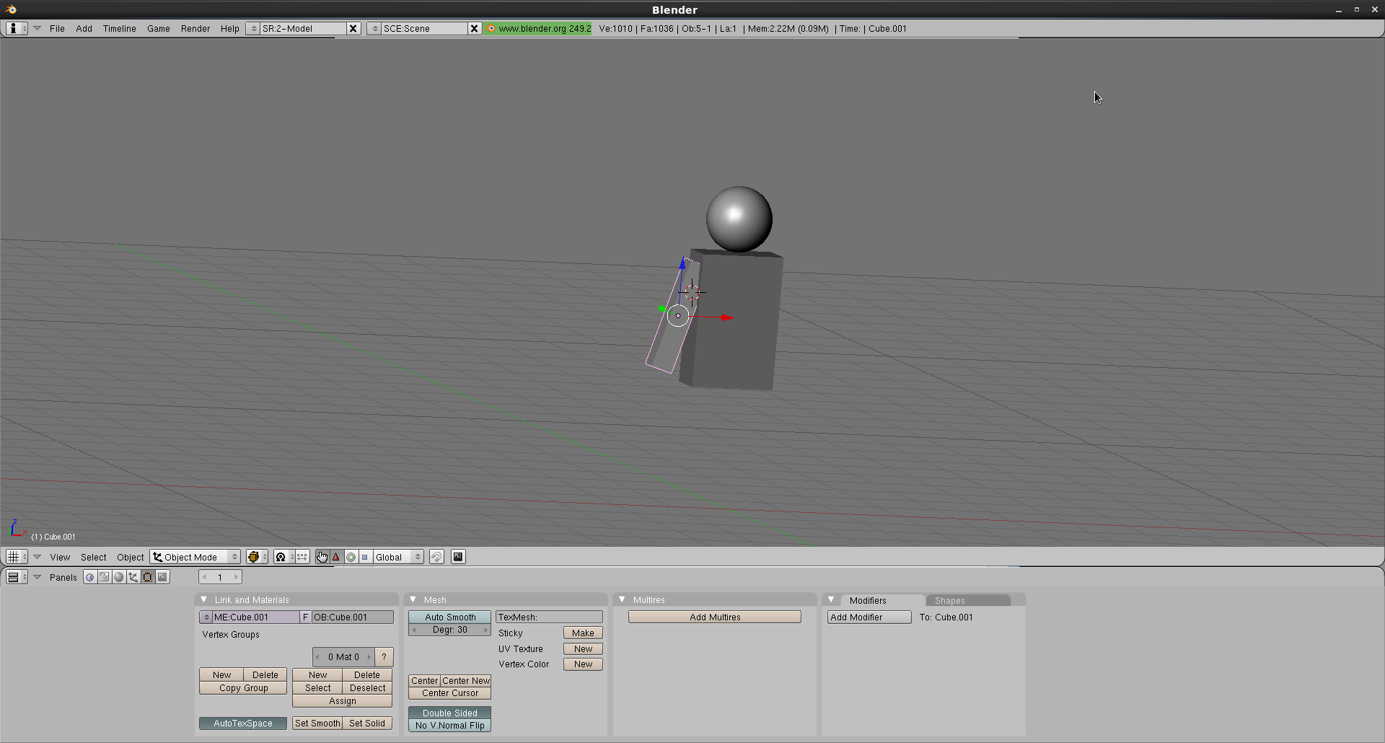
Then I duplicate (shift + D) the arm to make the other arm.

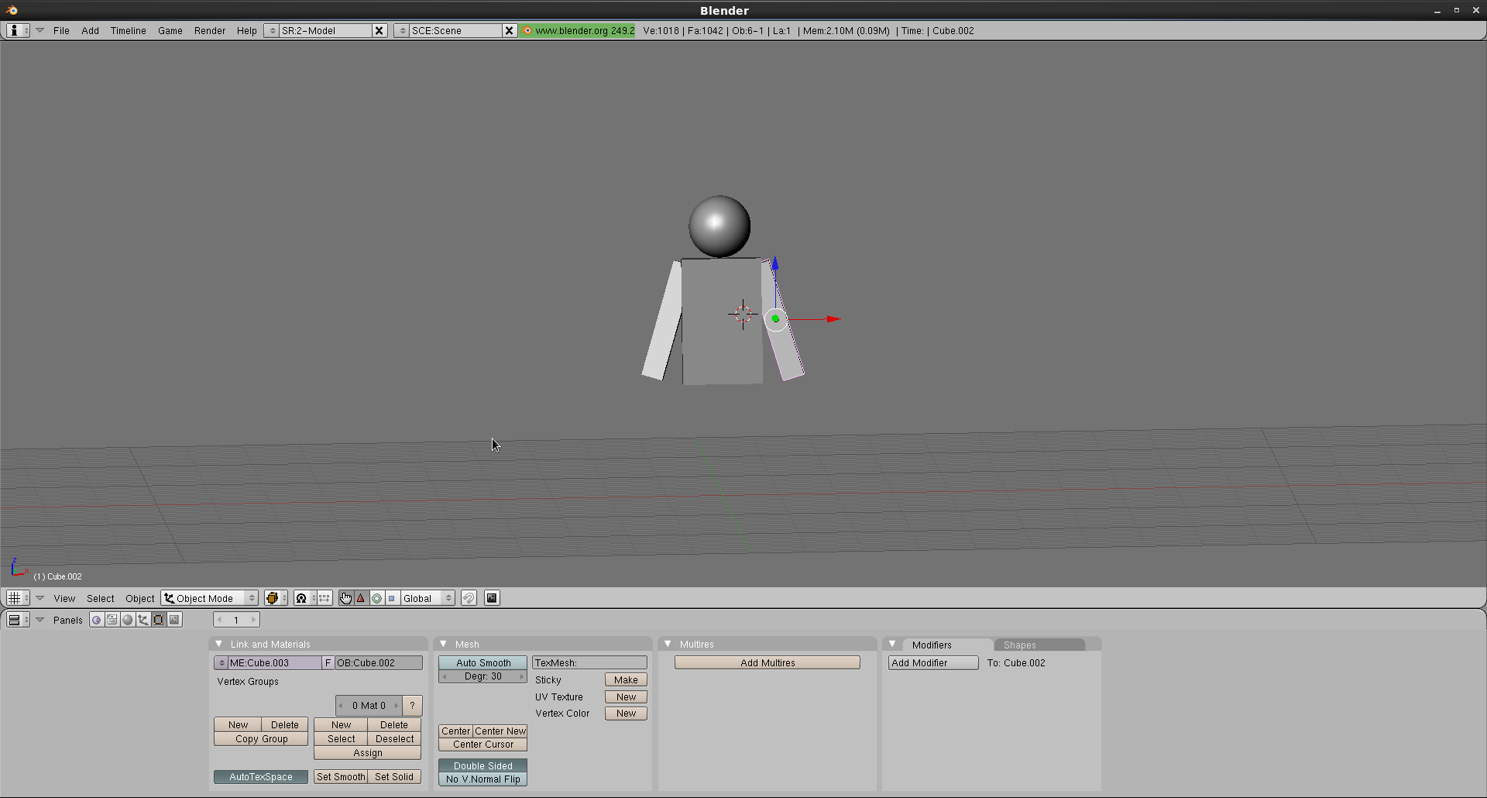

Then I go through the same steps to make two legs.

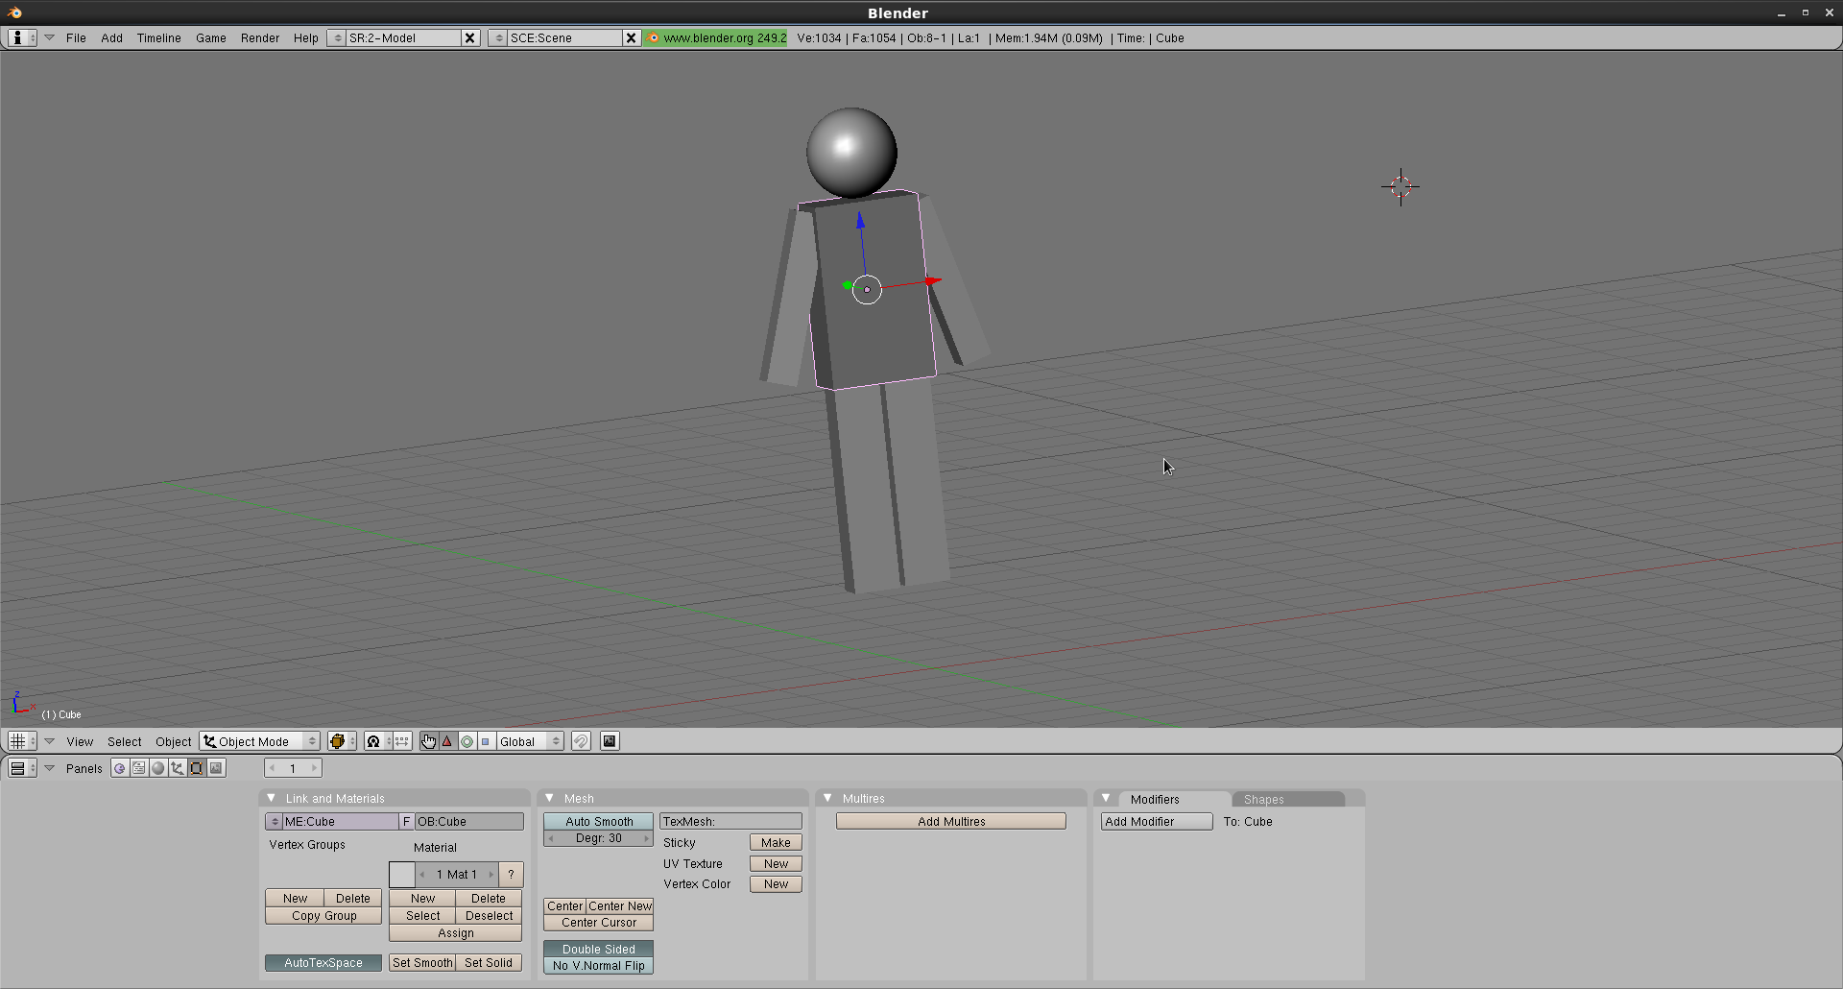

Next, I add two spheres to make them hands. Then make feet the same way, and modify the spheres to be more like feet.

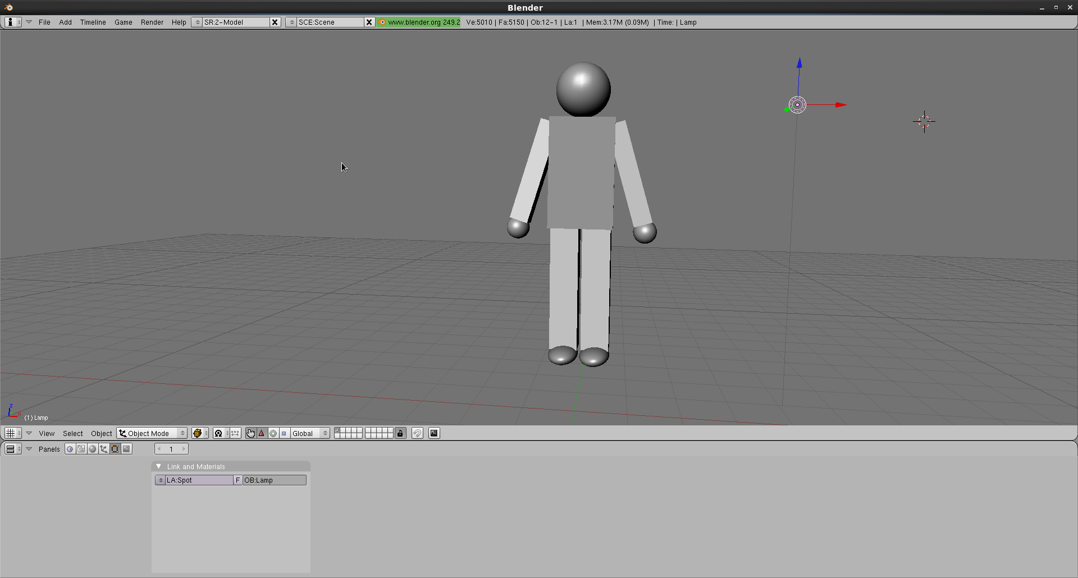

Next, use the same method to add lower arms and lower legs, and use four spheres as elbows and knees.
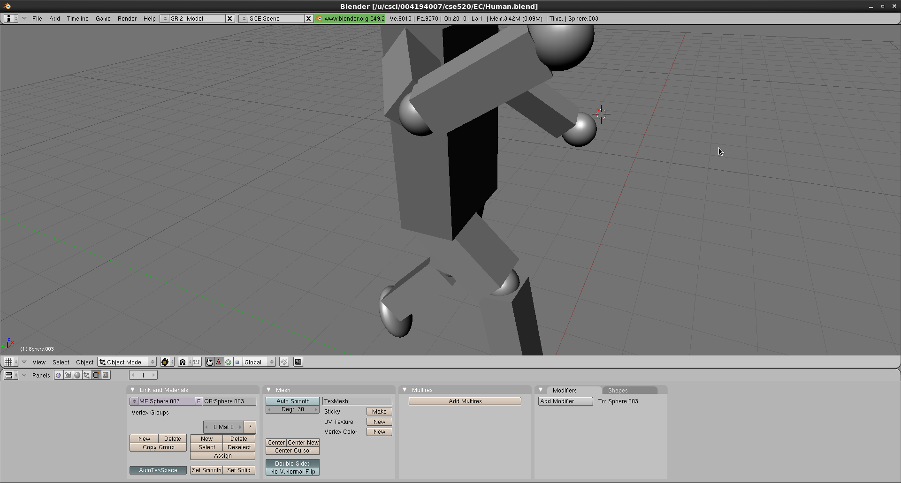

Finally, make some final modifications on the details to make the whole thing look better.

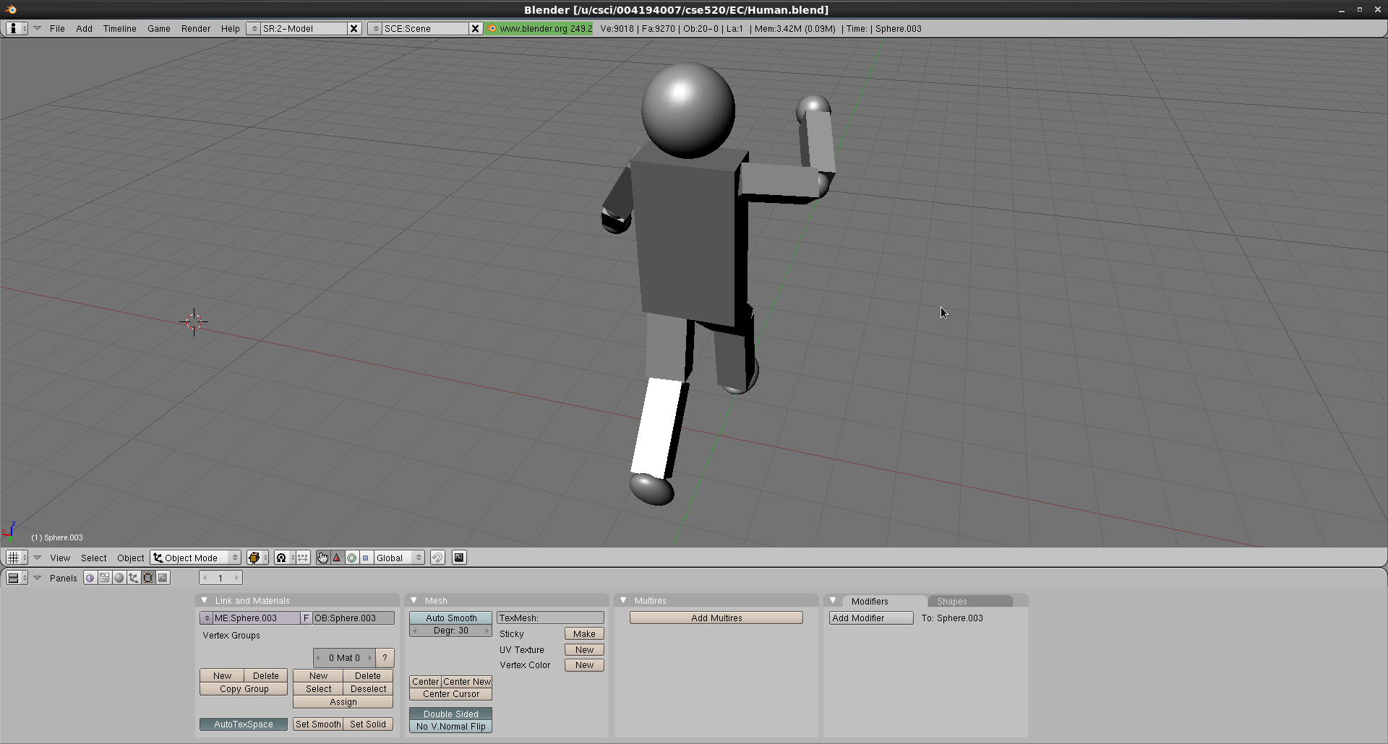

Report:
I successfully finished the first part of the extra credit homework.
At first I forgot to add lower arms and lower legs, fortunately I found it out and added them before I turn in the report. The report was going to be more thorough and with more pictures, but the system wouldn't let me turn in a file larger than 600K, so I had to cut it short. Overall, this is a pretty straight forward exercise. I will give myself full score for completing it.

